# Environment Setup

* Create a new database to upload your datasets into by running the following commands in SSMS:

USE [master]

GO

CREATE DATABASE [RedTech30]

* Run USE [RedTech30] to switch to using that database

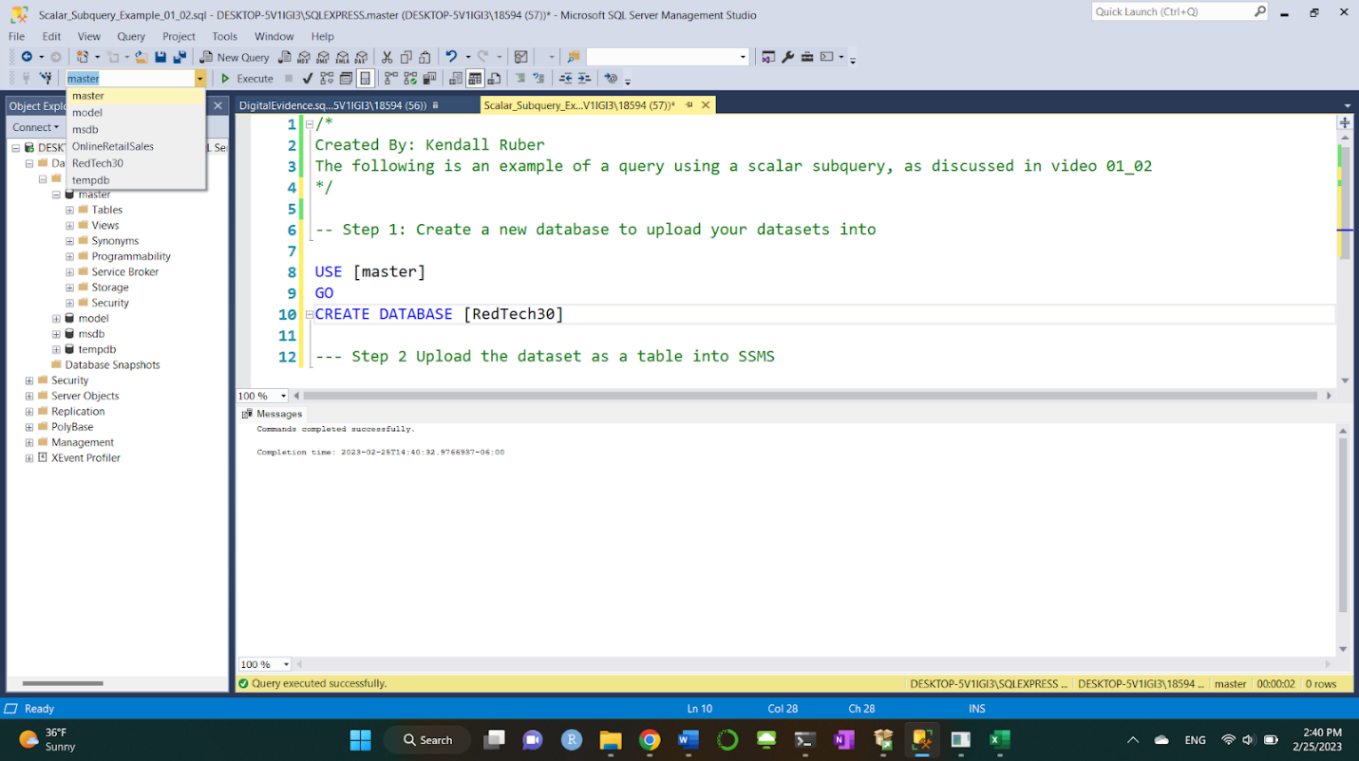

# Importing Data from an Excel File:

* Launch from the Start menu ("SQL Server 2017 Import and Export Data (64-bit)"): <https://learn.microsoft.com/en-us/sql/relational-databases/import-export/import-data-from-excel-to-sql?view=sql-server-ver16>
* Follow steps at: <https://www.sqlshack.com/import-data-excel-file-sql-server-database/>
* Opens up Import and Export Wizard
* Choose Microsoft Excel as your data source, and navigate to the file where you have stored the Online Retail Sales file.
* For the Destination, choose SQL Server Native Client 11.0. Your SSMS instance should be populated in the Server Name.
* From the Database drop down, choose the RedTech30 database you just created. Click Next . Next > Finish to complete the upload.

* To confirm the data was processed, you should see that there were 4,976 rows updated in the confirmation report

# Accessing the data

* Close the SSMS instance you had open before. Now reopen the program and sign in.
* On the left hand side, you should see RedTech30 as a database option. Under that you will see the table you just created, dbo.OnlineRetailSales$
* To view some data from this table to confirm the upload, run:

SELECT * FROM [RedTech30].[dbo].[OnlineRetailSales$]

* Repeat these steps for each of your datasets

Once all of the datasets are uploaded, you may notice that the tables do not have any primary key constraints. Run all of the code in Environment_Setup.sql at once to set these constraints.

That’s it! Congratulations, you have now finished setting up your database!